Create a webpage in a file called index.html about one of your favorite musicians, similar to the example below.

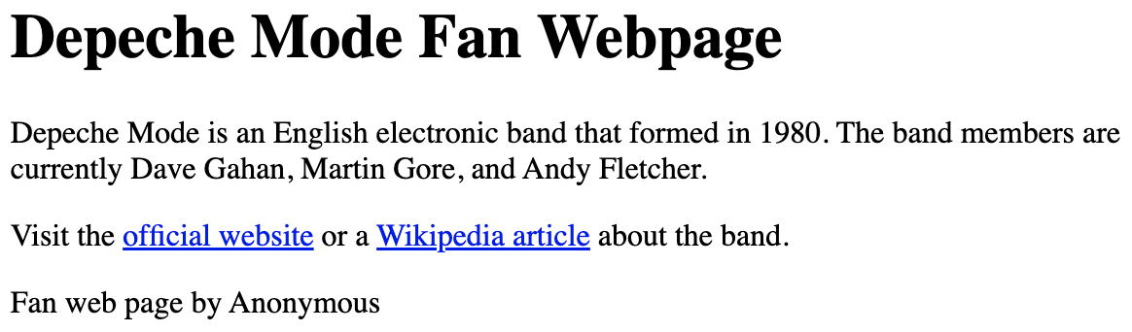

Use the following HTML containers:

* <header> with <h1> tags that contain the musician's name
* <main> with 2 paragraphs:
  + 1st paragraph gives some background information
  + 2nd paragraph links to at least one website about the musician
* <footer> that names the webpage's creator